ASHRAE typical limit for CO2 is 1000 ppm. 400+ is the global outdoor average in 2017 for reference.

**C:\Users\johns\Downloads\LAB5-Packet\LAB5 Packet\wallflower-pico-master**

Use file path for proper wallflower

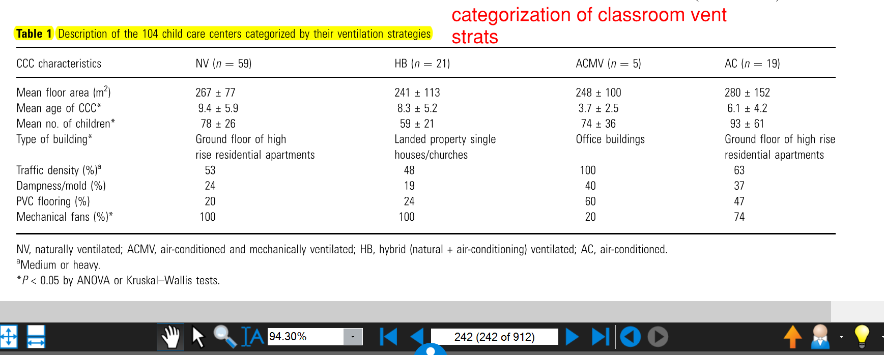

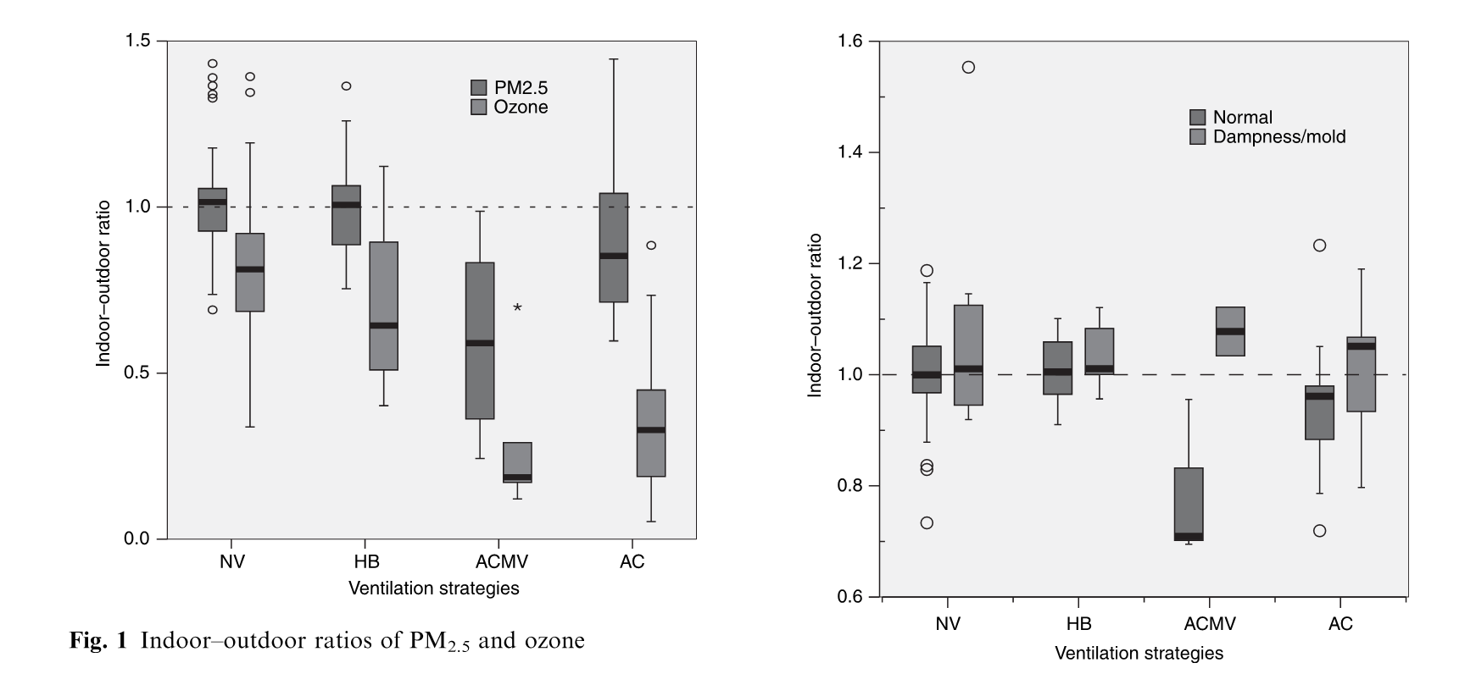



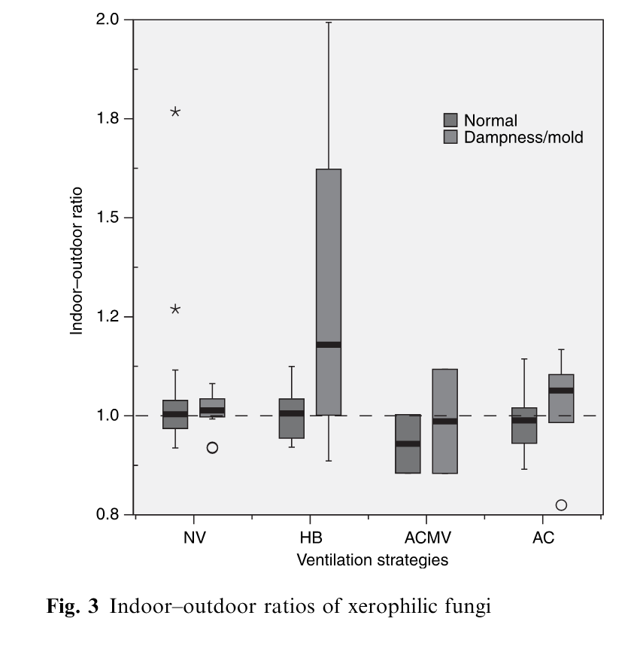

^ same paper as before. VERY telling graphs, widely cited

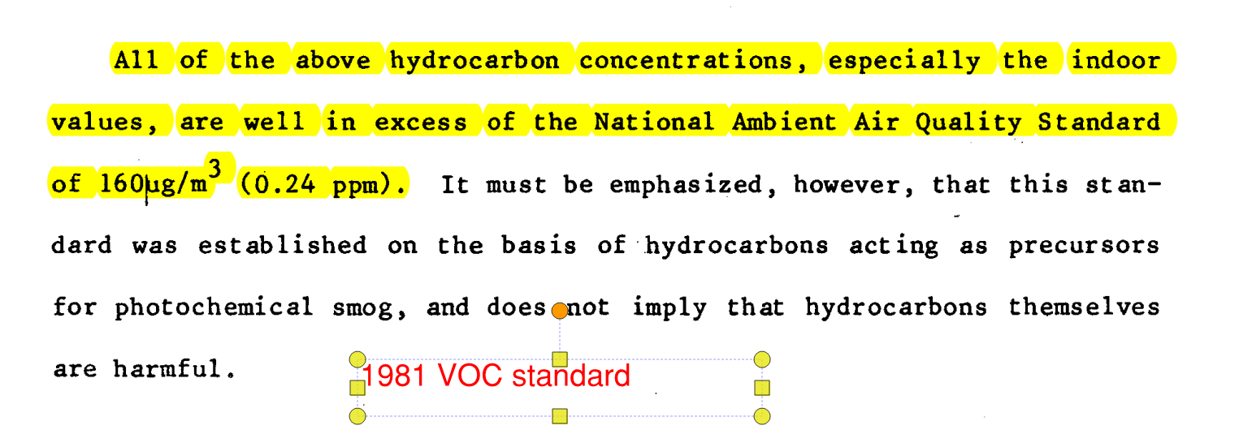

<https://www.usgbc.org/credits/retail-new-construction/v4-draft/eqp1> USGBC reqs

<https://www.google.com/search?biw=1280&bih=541&tbm=isch&sa=1&ei=ebnyWZSbHpXojwPd3oOIDQ&q=ashrae+maximum+indoor+pollutant+levels&oq=ashrae+maximum+indoor+pollutant+levels&gs_l=psy-ab.3...67030.70378.0.70487.23.23.0.0.0.0.143.2041.16j6.22.0....0...1.1.64.psy-ab..1.0.0....0.js6LXzS31xI#imgrc=ay2FbcqanSq48M>:

Also use IAQ GUide extensively

Schools IMPORTANT use this info in 249 folder

“The available measurements of ventilation rates and CO2 concentrations in schools suggest that, based upon the current ASHRAE ventilation standard, many classrooms are not adequately ventilated.”

“The pollutants most commonly measured in schools were TVOC, HCHO and microbiological contaminants.”

Study reviews several other studies linking these contaminants to asthma and SBS in students

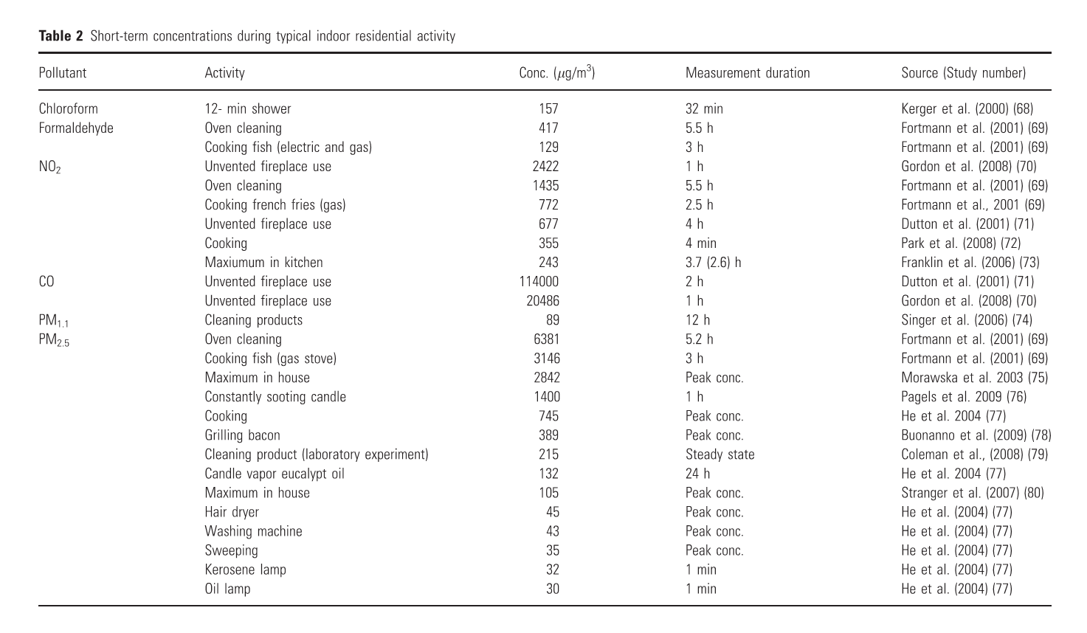

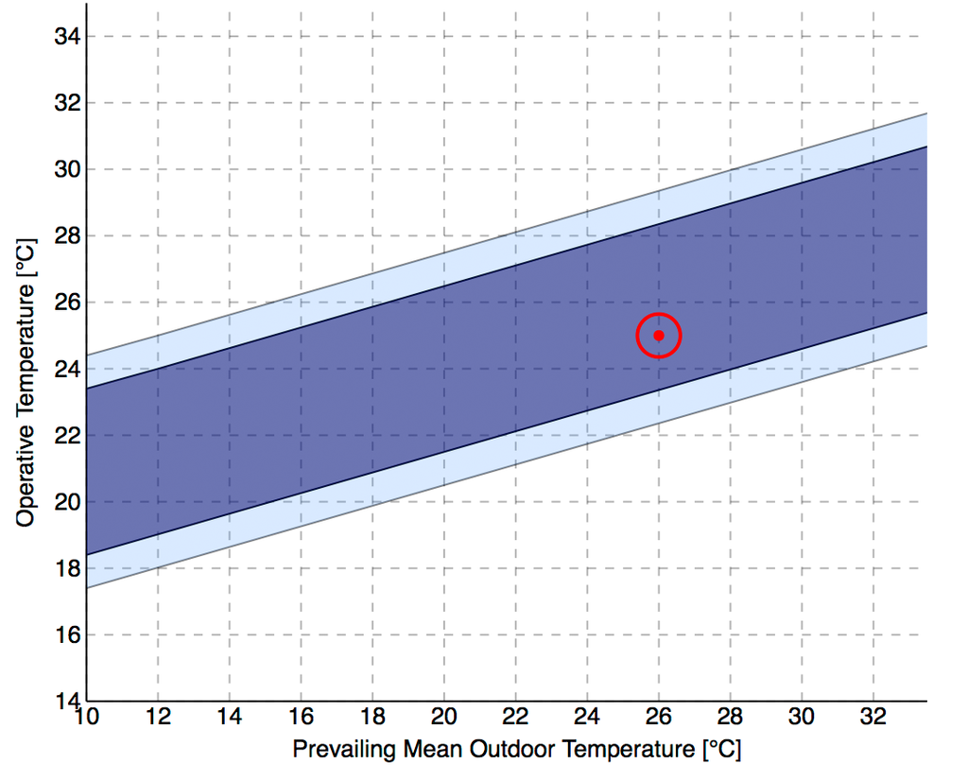

For Box fabrication

<http://www.makercase.com/>

<https://makeabox.io/>